ENGL 3110 - Exam One Study Guide - Spring 2025
Exam Overview
Total Points: 100
Time: 70 Minutes
Sections:
- Multiple Choice: 30 points (15 questions)
- Short Answer: 25 points (5 morphology questions)
- Sentence Labeling: 30 points (6 sentences)
- Essay: 15 points (1 question)

Section A: Multiple Choice Practice
Descriptive vs. Prescriptive Rules
Practice Question 1: Which of these is the best example of a prescriptive rule?
a. In English, past tense verbs often end in "-ed"
b. In English, the subject usually comes before the verb
c. In formal English, you should never end a sentence with a preposition
d. In English, speakers often use "um" and "uh" as filler words

Practice Question 2: Which of these is the best example of a descriptive rule?
a. Good writers avoid using passive voice
b. In English, adjectives typically appear before nouns
c. Educated speakers never use double negatives
d. In academic writing, contractions should be avoided

Open and Closed Classes
Practice Question 3: Which word belongs to an "Open Class"?
a. Behind
b. Fantastic
c. Those
d. Him

Practice Question 4: Which word belongs to a "Closed Class"?
a. Running
b. Beautiful
c. Under
d. Scientist

Parts of Speech Identification

Practice Question 5: In the sentence "The small child quietly read her favorite book," which word is functioning as an adverb?
a. Small
b. Quietly
c. Favorite
d. Book

Practice Question 6: In the sentence "My older brother works at the local hospital," which word is functioning as a preposition?
a. Older
b. Works
c. At
d. Local

Section B: Morphology Practice
Instructions: Divide each word into morphemes and identify each as "free" or "bound."
Practice Question 7: "untrusting"
- Un – Bound
- Trust – Free
- -ing - Bound

Practice Question 8: "players"
- Play – Free
- -er – bound
- -s bound

Practice Question 9: "misunderstood"
- Mis- bound
- Understood – free
- Understand

Section C: Sentence Labeling Practice
Instructions: Complete the tables below and then create a diagram of the sentence following the method we have used in class.
Key
Parts of Speech  - Noun = N  - Verb = V  - Adjective = Adj  - Adverb = Adv  - Determiner = Det  - Preposition = Prep  - Pronoun = Pro  - Interjection = Intj  - Conjunction = Conj  - Relativizer = Rel  - Complementizer = Comp  Phrase Types  - Noun Phrase = NP  - Verb Phrase = VP  - Adjective Phrase = ADJP  - Adverb Phrase = ADVP  - Prepositional Phrase = PP | Roles  - Subject = Subj  - Predicate = Pred  - Adverbial = Advl  - Subject Complement = SC  - Direct Object = DO  - Indirect Object = IO  - Object Complement = OC  Clauses  - Sentence = S  - Independent Clause = IC  - Dependent Clause = DC  - Relative Clause = RC  - Complement Clause = CC

Notes
- You are always encouraged to look over the example diagrams and other handouts found on the front page of Canvas to assist you with diagramming and labeling.
- As we discussed in class, some of the “phrase” boxes may not cover all of the words in that phrase. Please make your decision by identifying the headword of the section contained under that box. Use that headword to determine the type of phrase and, when necessary, its role in the sentence.
- You do not need to include the “roles” in your diagram unless you are specifically asked.
- Always include a phrase level for nouns, verbs, adjectives, adverbs, and prepositions
- Label Possessive Nouns as Nouns with an NP even though they appear in the determiner position
- Some parts of speech fill the role for other parts of speech. For instance, a verb can take a noun position and serve as a subject. In this case, either label is ok on the diagram, as long as the lines are in the right position.

Practice Question 1: The young artist painted beautiful landscapes.
Phrase | NP |  |  | VP | ADVP
Word | The | young | artist | painted | quite | beautifully
Part of Speech | Det | Adj | N | V | Adv | Adv

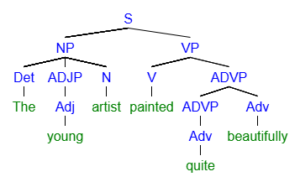
[S [NP [Det The] [ADJP [Adj young]] [N artist]] [VP [V painted] [ADVP [ADVP [Adv quite]] [Adv beautifully]
Practice Question 2: Wisdom comes to us through difficult experiences.
Phrase | NP | VP | PP |  | PP
Word | Wisdom | comes | to | us | through | difficult | experiences
Part of Speech | N | V | Prep | Pro | Prep | Adj | N

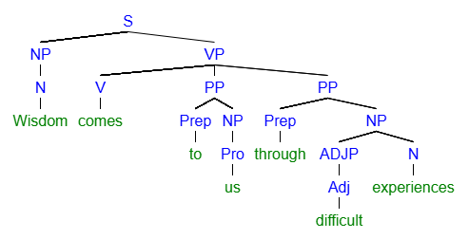
[S [NP [N Wisdom]] [VP [V comes] [PP [Prep to] [NP [Pro us]]] [PP [Prep through] [NP [ADJP [Adj difficult]] [N experiences]
Practice Question 3: Three ambitious students from Pueblo study in the library.
Phrase | NP |  |  | PP |  | VP | PP
Word | Three | ambitious | students | from | Pueblo | studied | in | the | library
Part of Speech | Det | Adj | N | Prep | N | V | Prep | Det | N

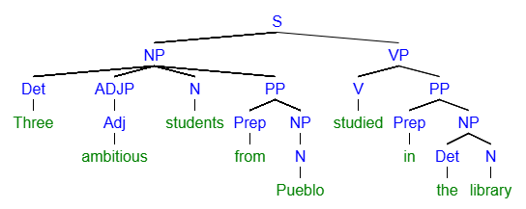
[S [NP [Det Three] [ADJP [Adj ambitious]] [N students] [PP [Prep from] [NP [N Pueblo]]]] [VP [V studied] [PP [Prep in] [NP [Det the] [N library]

Practice Question 4: Jimmy sat in the chair with in broken leg.

Phrase | NP | VP | PP |  |  | PP
Word | Jimmy | sat | in | the | chair | with | the | broken | leg
Part of Speech | N | V | Prep | Det | N | Prep | Det | Adj | N

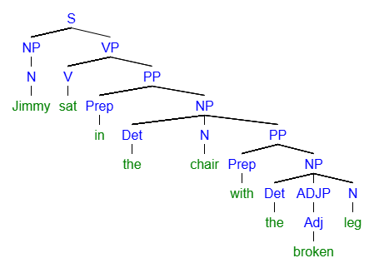
[S [NP [N Jimmy]] [VP [V sat] [PP [Prep in] [NP [Det the] [N chair] [PP [Prep with] [NP [Det the] [ADJP [Adj broken]] [N leg]

Essay Section Overview : The essay question will present you with a scenario involving the concepts from early in the unit (see below):
- Take a clear position supporting either the author or editor
- Apply key concepts from Unit One, including:
  - Descriptive vs. prescriptive approaches to grammar
  - Language variation and dialects
  - Standard vs. non-standard varieties
  - Linguistic privilege and power
- Write 200-250 words (approximately 12-15 sentences)
- Use specific examples and reasoning to support your argument
Key concepts to review:
- Prescriptivism: The belief that there are "correct" and "incorrect" ways to use language, often based on formal written standards
- Descriptivism: The approach that studies how language is actually used by speakers, without judgment
- Dialect: A variety of language associated with a particular region, social group, or community
- Standard variety: The form of language typically used in formal, institutional settings
- Linguistic privilege: The advantage gained by speakers whose language variety matches the prestige or standard form
Sample essay prompt themes you should be prepared to discuss:
- Should authors change their characters' authentic speech to match "standard" English?
- How do editorial decisions about language reflect broader social attitudes?
- What is the relationship between "correct" grammar and effective communication?
- How do prescriptive rules sometimes conflict with natural language variation?

Study Tips
- Review class notes on the difference between how language works (descriptive) vs. how people think it should work (prescriptive)
- Practice identifying word classes: Remember that open classes (nouns, verbs, adjectives, adverbs) regularly gain new members, while closed classes (determiners, prepositions, pronouns) rarely do
- Focus on function over form: A word's part of speech depends on how it's used in a particular sentence, not just its typical category
- Break down complex words: Look for prefixes, roots, and suffixes when analyzing morphemes
- Consider multiple perspectives: For the essay, think about both the practical concerns (readability, audience expectations) and the social justice concerns (representation, linguistic discrimination) involved in editing decisions

